Salsa  Salsa  Salsa  Salsa  Salsa  Salsa  Salsa  Salsa  Salsa  Salsa  Salsa  Salsa  Salsa  Salsa  Salsa  Salsa  Salsa  Salsa  Salsa  Salsa  Salsa  Salsa  Salsa | 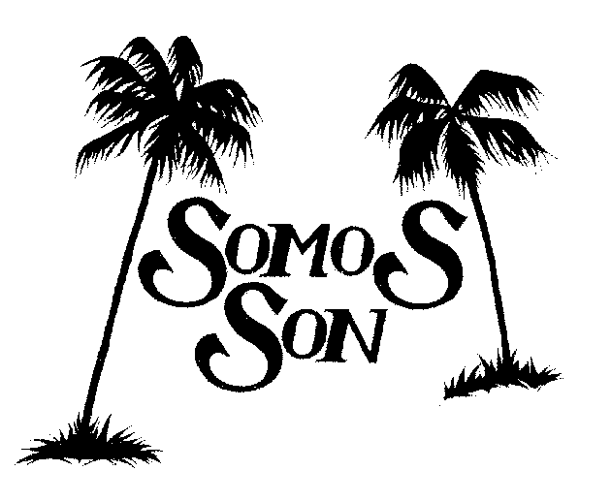  Somos Son, one of Santa Barbara’s hottest bands, brings the exciting dance rhythms of Cuba to the South Coast. The group, whose name translates as “We are Son,” plays the traditional Cuban Son dance music, as well as contemporary salsa. The band features the popular Jose Elizarraraz and Hugo Macario on vocals and percussion in addition to Raul Rico, Jr., timbales; Roberto Gutierrez, congas; Ariel Moya, bongos; Karl Schiffmann, piano; Malcolm Ian Peters, bass; and Barry Nitikman and Jonathon Dane, trumpets. The group has performed at many venues including Soho, Ruby’s, Bacara, and the Granada. Get ready to dance to this great rhythmic and salsa music ensemble playing traditional son and modern salsa.  Somos Son comes to play, you come to dance!  SOhO  Friday March 6, 2009 9:30pm  1221 State Street # 205, Santa Barbara, CA | Salsa  Salsa  Salsa  Salsa  Salsa  Salsa  Salsa  Salsa  Salsa  Salsa  Salsa  Salsa  Salsa  Salsa  Salsa  Salsa  Salsa  Salsa  Salsa  Salsa  Salsa  Salsa  Salsa

